USEME file: Interactive Controller

Main Class
Run -> Edit Configurations -> type “-interactive”

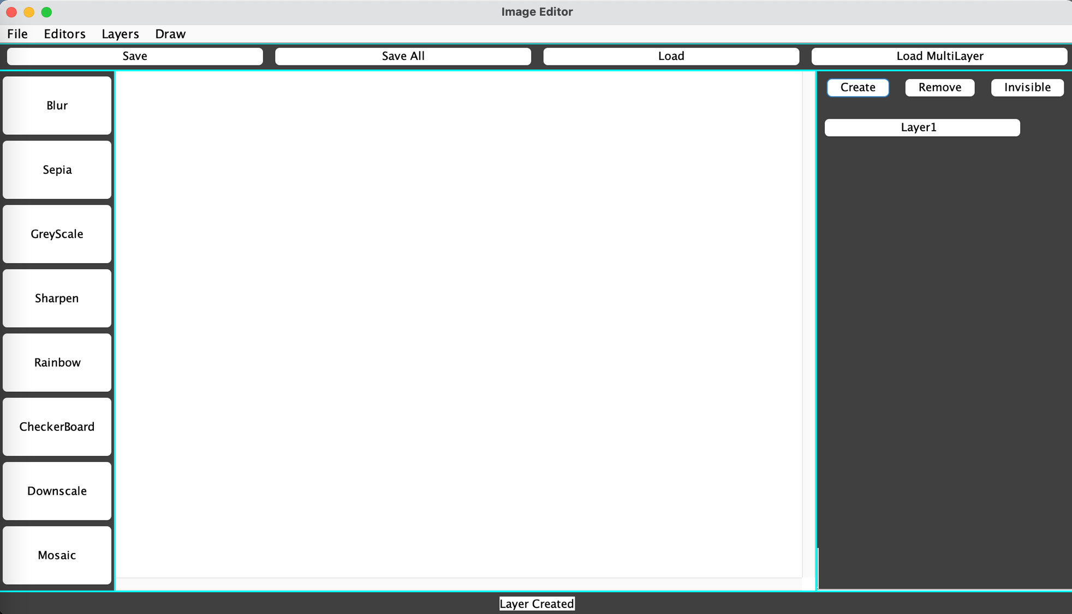
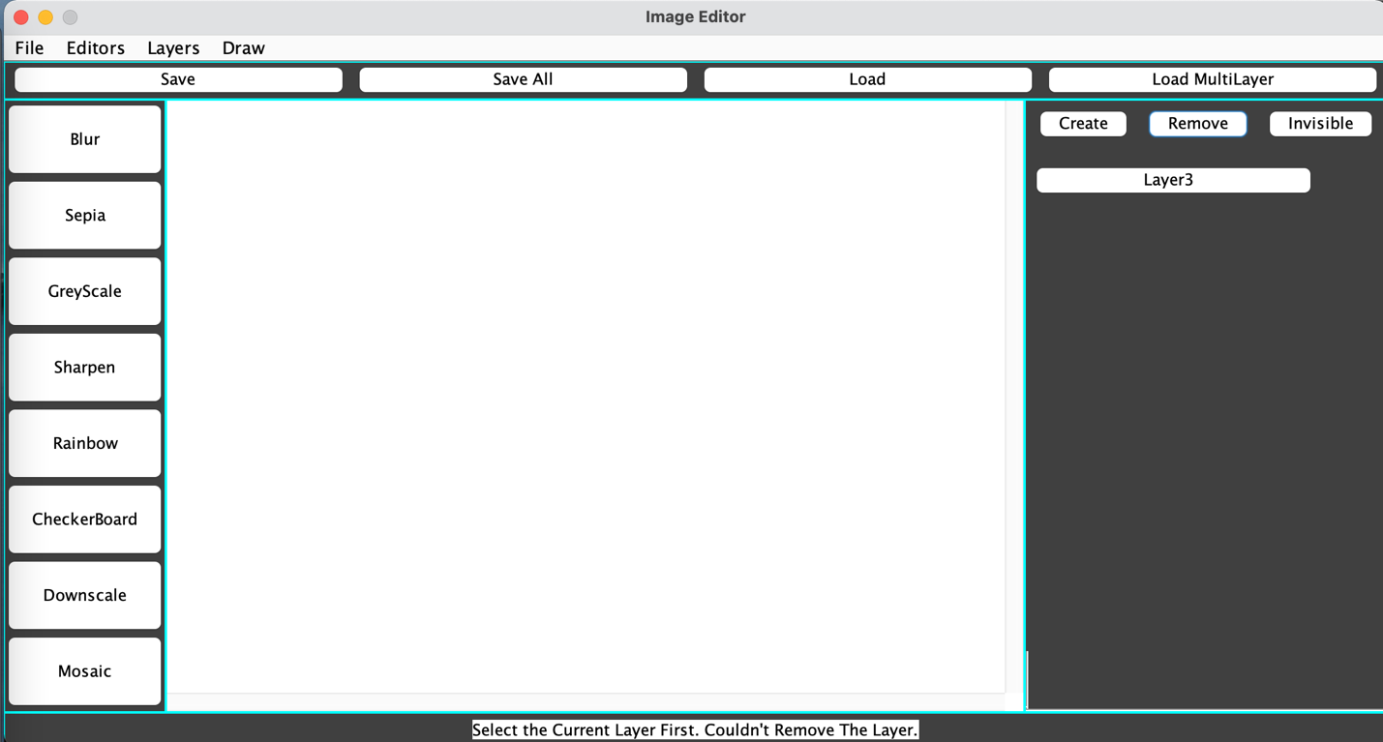
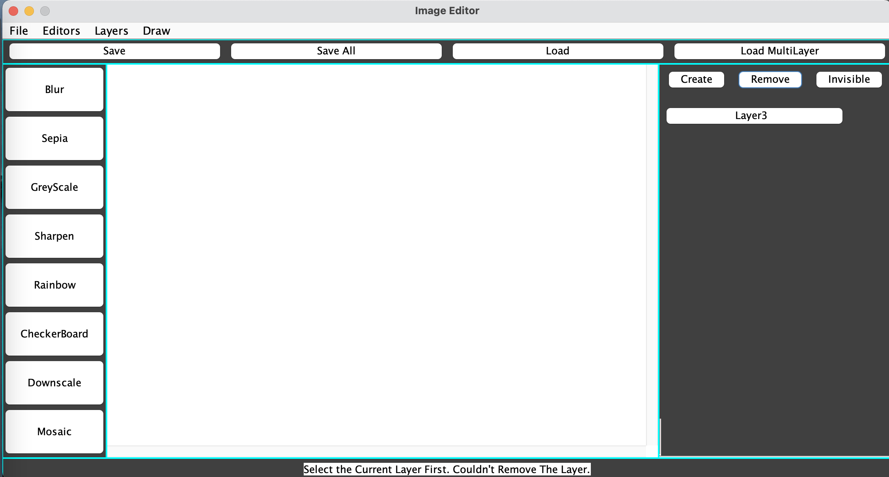
Program
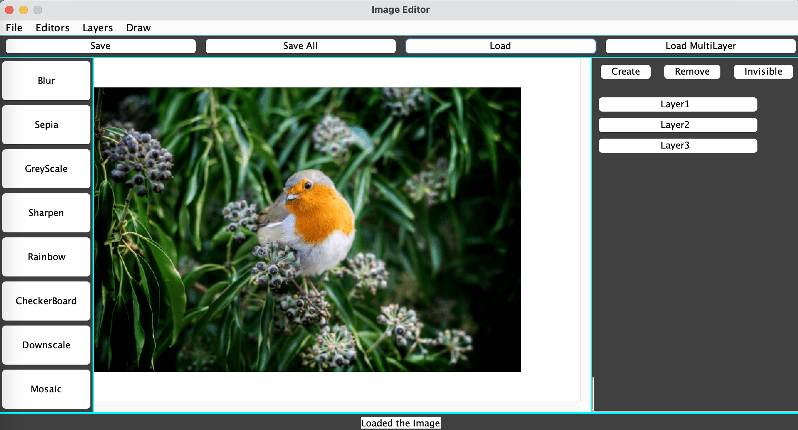
** The image editor sends the user messages that may help them when using the program*

- Create a Layer: You must create a layer before loading an image/applying filter (except for cases such as: drawing checkerboard or rainbow and loading multilayer all at once)
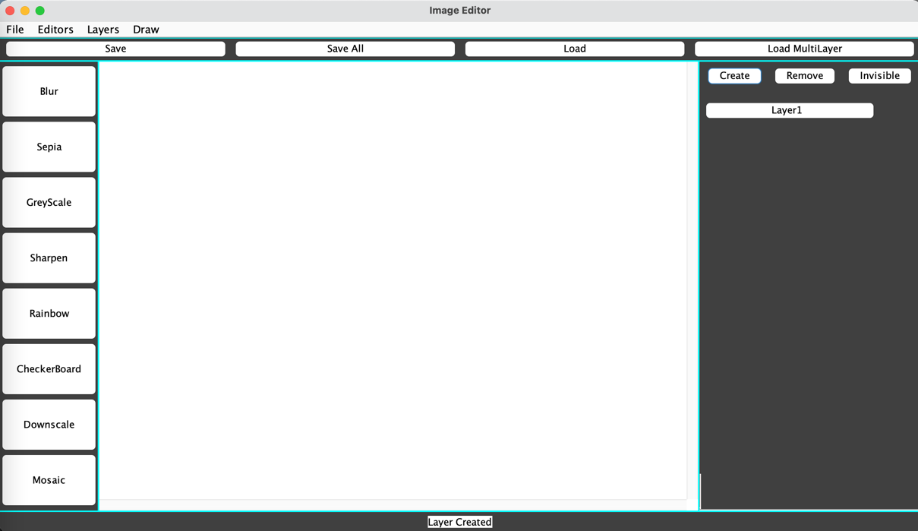

- Choose the load option and load the image from the “res” folder. The main folder should be
the res folder (all relevant files are in the res folder).
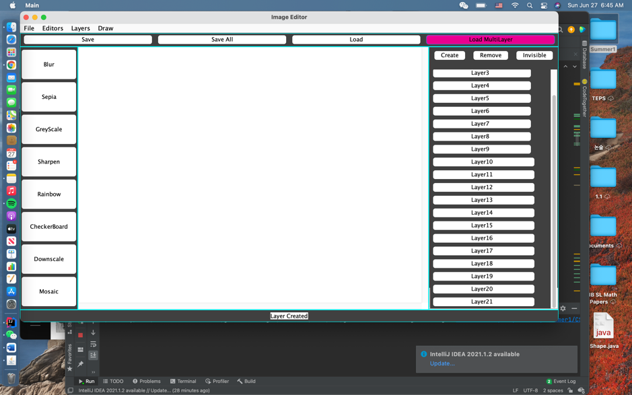
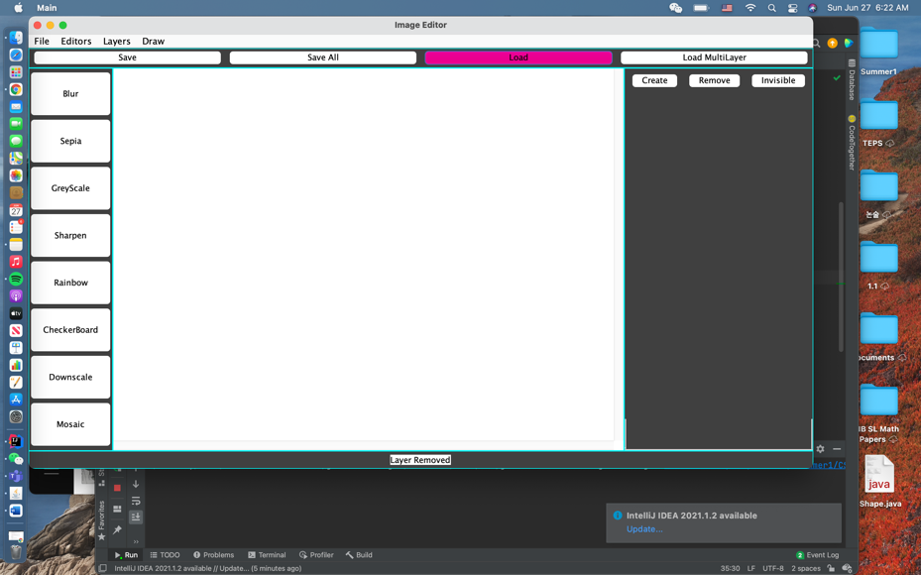
** LOAD/ LOAD MULTILAYER: file chooser will appear once these options are clicked. Choose the appropriate file and load it to the editor.

File Menu: ** Load Batch (loading batch script) is only in the menu options. There’s no button for this option. However, all other functionalities are supported with buttons. **
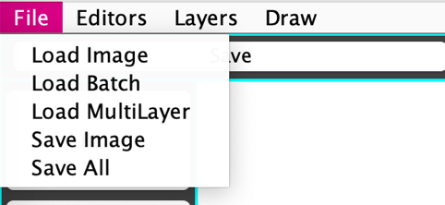

The image is scrollable if it is bigger than the image pane.
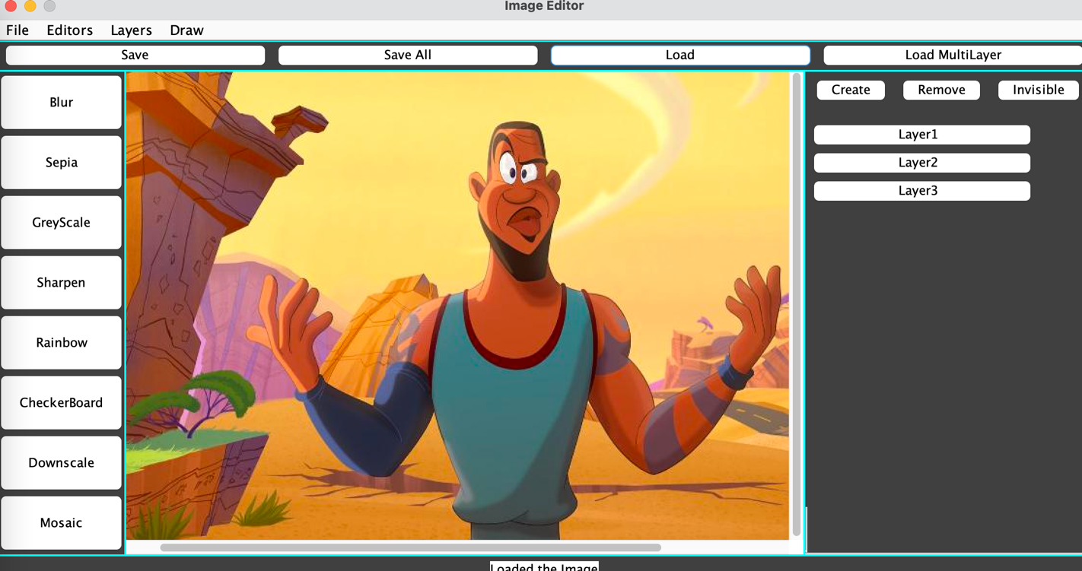

- Once you load the image, you can select the editors to edit the image. Blur, Sharpen, GreyScale, Sepia do not need the user to type in parameters. However, methods such as Downscaling, and Mosaic require specific inputs such as the number of seeds and new width and height. There will be a field to type these options as shown below.

  - Editors Menu: Contains all the image editors. The image editor buttons are on the right of the image pane.
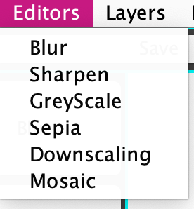
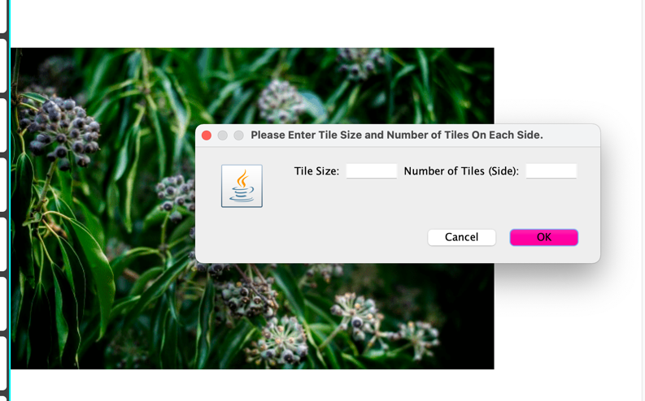

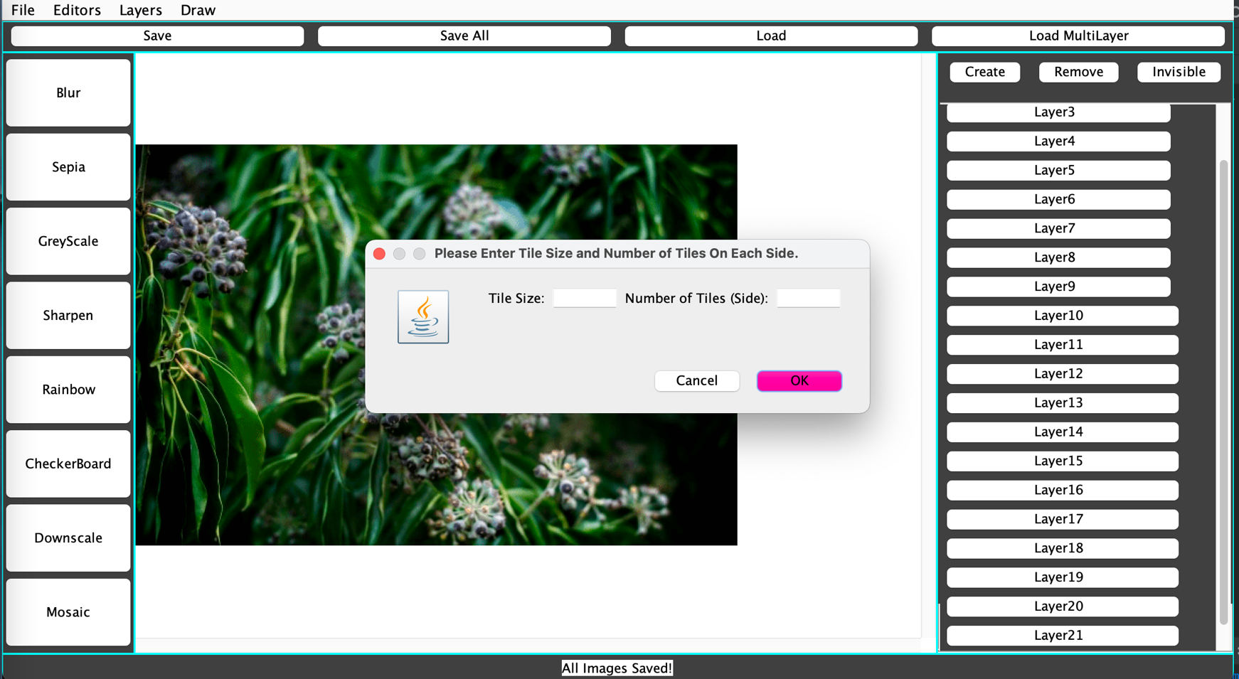

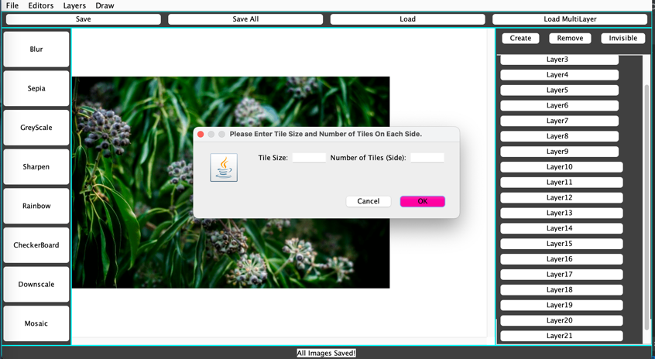

**RAINBOW: Height needs to be a factor of 7 **

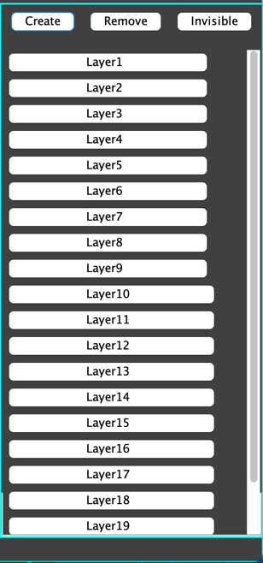
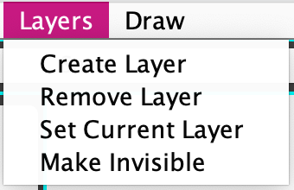
  - Layers Menu: contains all methods relating to layers.
** SET CURRENT: There is not button for setting the current layer, but clicking on the created layer button will set that layer to be the current layer.

** REMOVE: click on the layer you want to remove. Then click on the remove button. If you don’t select the next layer you want to delete after removing one layer, then the program will automatically assign the next layer to be deleted. If there is no next layer, the current layer will be set to null and you have to select the layer you’d like to remove.

** INVISIBLE: this will make the layer invisible. Clicking it again will make it back to be visible.

- After editing, save the image by using the save all or save method. You can either use the menu bar or the save and save all buttons.

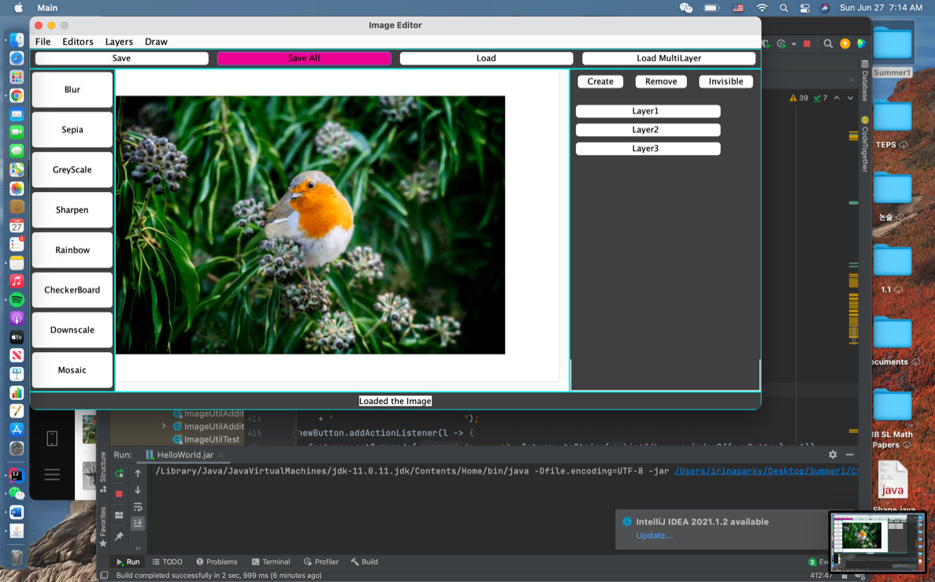
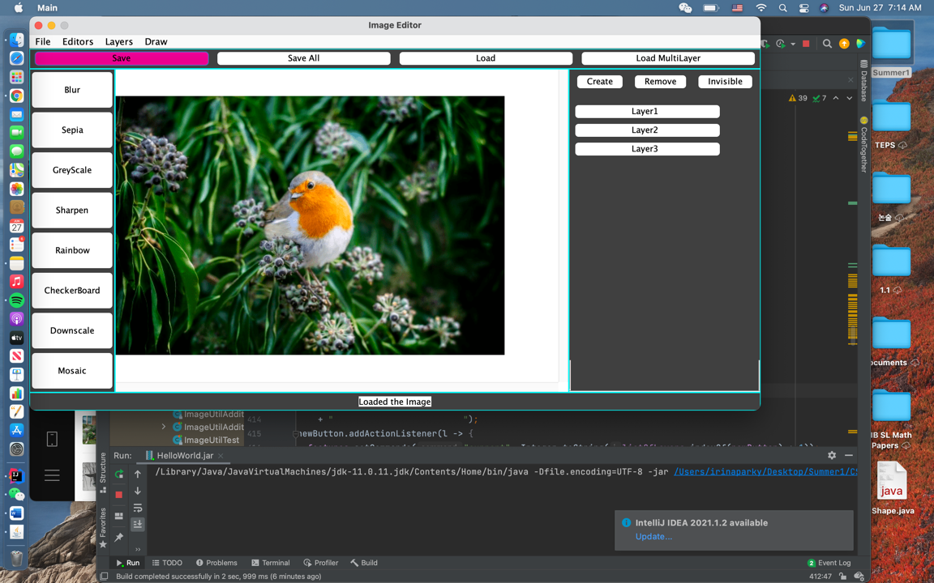
** SAVE/ SAVEALL: file chooser will appear once these are clicked. For SAVE option, you DO have to TYPE the file type “.png”, “.jpeg”, “.ppm” at the end of the file name. However, for the SAVEALL option, the only file type is txt. Therefore, you ONLY type the file name.

